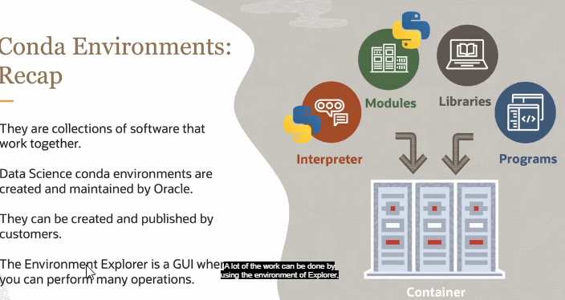
Manage Conda Environments

Hello. My name is John Peach, and I'm a data scientist on the Oracle Cloud Infrastructure Data Science Service team. In this module, you will learn how to manage conda environments using the odsc command line tool. Let's recap what conda of environments are.
They are a collection of software that are bundled together. In the Data Science Service, there are conda packs that are managed by the Data Science Service team, and there's also kind of packs that you can publish yourself. A lot of the work can be done by using the environment of Explorer, which is a GUI to manage these conda environments. However, more control is given to you using the command line odsc command.

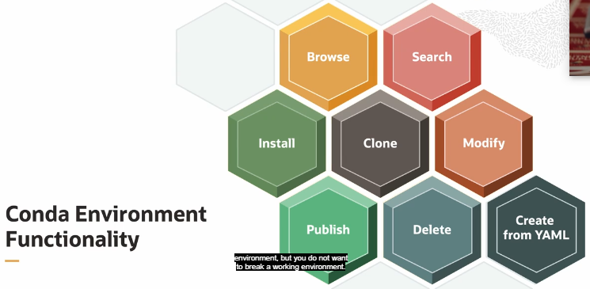
There's a lot of functionality within the data science conda management environment. And you can do things such as browse, which allows you to access detailed information about conda environments in a YAML format. It also provides information on a data science, published, and install conda environments.
You can perform searches. Use the command line tools such as grep to browse capabilities to search the conda environments. You can install conda environments, either the data science conda environments, or the published conda environments. You can clone environments. So you can copy and install a conda environment to another location.
This is a handy feature when you want to make major changes to the conda environment, but you do not want to break a working environment. You can modify a conda environment. You can change the contents of an installed conda environment, for example, when you want to upgrade a software package.
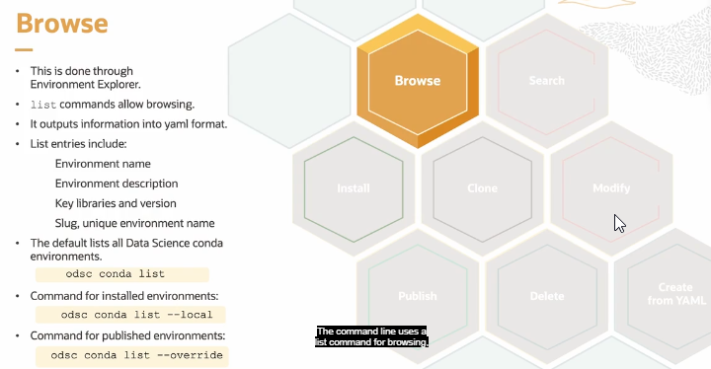
You can publish a conda environment, where you store your customized conda environments and object storage. This allows you to share it with others, and use it in model deployment and jobs. Obviously, you need to be able to delete your conda environments, and that's done through the command line as well. You can also create custom conda environments using a conda YAML file. And we'll talk about how to do that.

Let's talk about browsing conda environments. So you can do this through the environment Explorer, or you can do it through the command line. The command line uses a list command for browsing, and it gives you all kinds of information about the conda environment, such as the name, its description, what are the key libraries, and what the slug is, where the slug is the unique environment name.
By default, you would use the command odsc conda list, and this would give you detailed information about the data science conda environments. If you're looking for information on what conda environments you have installed, you would use that same command, odsc conda list. But in this case, you provide the optional parameter local.
This will limit it to just the conda environments that are installed on your notebook. To access published conda environments, you would use the odsc conda list override to override the default setting of providing data science conda environments to provide published conda environments. For this command to work, you'd have to have set up the object storage bucket and odsc conda in it to configure where the published conda environments are.

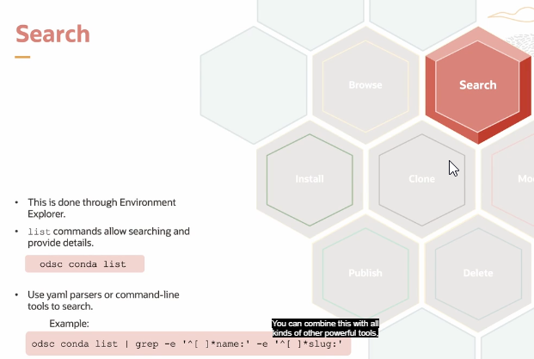
Searching. There's no specific command for searching in the command line, but you can do searches through the environment Explorer. To do it on the command line, you would do the odsc conda list command, and then you compare that with different command line tools such as grep to search for different parts of the YAML file.
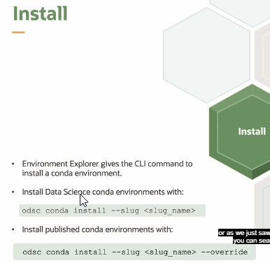
So in the example that we have down here, odsc conda list pipe grep e, and then some regular expression to capture the name tag, and then another regular expression to capture the slug tag, will result in listing of all the names and slugs for all the data science conda environments. You can combine this with all kinds of other powerful tools, such as Arc and PEARL to access the information that you want.

Installing conda environments. This is done through the command line using the odsc conda install command. You provide the slug option and the name of the slug. You can get the name of the slug through the environment Explorer, or as we just saw in searching, you can search for it.
If you would like to install conda environment that you have published to your object storage bucket, use the odsc conda install slug, the name of the slug, and then the override parameter. And that will override the default behavior of installing data science conda environments and install a published conda environment instead.

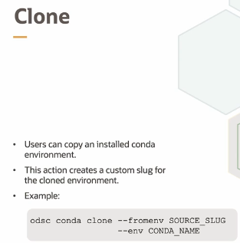
Cloning conda environments. Users can copy and install conda environment. This action creates a custom slug for the conda environment that you've cloned. So this is done by calling odsc conda clone, and then you need to specify the source slug using the from environment command line option.
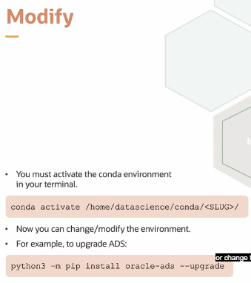
The source slug is the slug of the installed conda that you want to clone, and then you can give your new conda environment a new name using the env option. This will automatically create a new slug for you, and you'll be able to identify the conda environment by the conda name that you've given it.

Modifying a conda environment. It is common practice that you install a conda environment and you want to install a new piece of software or change the version of something. This is not done through the odsc command line tool, instead it's done through the conda tool.
So the first thing you need to do is call conda activate and pass the path to the conda environment that you want to work with. So by default, that's stored in /home/datascience/conda/ and then the slug is the folder name. This will in the terminal basically activate the conda environment, so any changes you do will change that conda environment only.
So for example, if I wanted to upgrade ADS to the latest version, I would do conda activate, and then the path to the conda environment that I want to change. And then I would do python3 -m pip install oracle-ads upgrade. And this would upgrade my version of ADS.

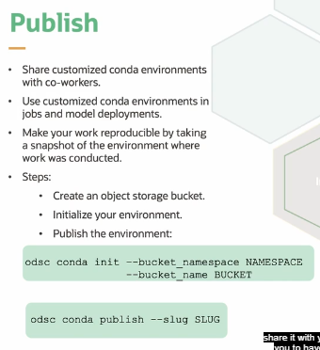
Once I've cloned and modified a conda environment, I might want to publish it. Publishing it takes the conda environment and moves it into an object storage bucket that you can share with others. It allows you to run these conda environments in jobs, it allows you to have model deployments using them, share it with your coworkers, and allows you to have reproducible research.
So the first thing you need to do is you need to initialize the conda bucket that you're going to use. So you would go into the console, go into your object storage buckets, and you would create a bucket where you want to publish your condas to.
From there, you would capture the namespace that's being used, and the bucket name that you've created. Then you go to your terminal, and you only have to do this once in a notebook session. You call odsc conda and init, which is going to initialize where the published condas go.
You use bucket_namespace, and you give it the namespace for your bucket. And then bucket_name, and you give it the actual name of your bucket. Once that's done, the system knows how to communicate with your object storage bucket.
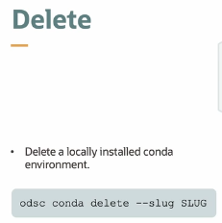
To publish your conda, you very simply call odsc conda publish, and then --slug, and then the name of the slug that you would like to publish. This will bundle up the conda environment and push it to your object storage.

If you no longer need a conda environment and want to free up some space, you can delete it.
To delete it, you call odsc conda delete, and then you give it the name of the slug, and this will delete the conda environment for you.

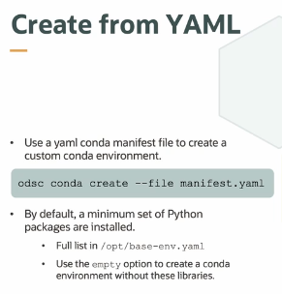
One way that you can create a conda environment is by cloning it, another way is by modifying it, or you can create a conda environment from scratch.
And you do this by using the odsc conda create, and then you give it the file name command line option, plus the conda manifest YAML file. So this is just your standard conda manifest that you would use to create a conda in any other system.
By default, the odsc conda create will install some base packages that are stored in /opt/base-env.yaml. You can use the --empty option to prevent this from installing it. What isn't there are the essential packages that are needed to work with the notebook session.
So let's wrap up. We've talked about various conda environment functionalities, such as browse, install, clone, publish, delete, and more. We've discussed using odsc command to perform many of these operations. And we've showed you how to combine the odsc command with other Unix commands to do searching for the environment that you're looking for. Thank you very much.

